Reconsider the Grid Workshop
Sarah Nishiura October 23, 24, 2019
From the use of one point perspective as a compositional tool in Renaissance Italy, to the fantastic Op Art creations of the 1960s, artists have been finding ways to manipulate the standard square based grid for centuries as a means of introducing space and movement into two dimensional design. This workshop will introduce you to some simple ways to enrich designs by stretching, warping, and re-imagining the grid.
Workshop will include discussion of the use of the grid in art history and quilt history, exercises on paper that will demonstrate simple ways to manipulate the grid, and open work time to try out some basic templates provided by Sarah, and to work on creating your own.
Materials List
Materials needed:
- For making samples on day one, at least 1 yard white or other very light colored fabric and at least 1 yard darker fabric (Prints or solids are fine, a mix of smaller pieces is fine. No need to bring anything too precious or expensive. We are just looking for strong contrast to best illustrate the graphic elements of these exercises.
- On day two, if you want to work on a more realized design, bring the fabrics of your choice. Keep in mind fabrics that contrast strongly with each other will yield the most graphic results.
- Graph paper (8 squares per inch format is helpful but not necessary) and something to draw with.
- The usual basics: ruler, rotary cutter, cutting mat, marking pens or pencils, pins, etc.
- Sewing machine with basic supplies or hand piecing supplies, whichever you prefer.
For the room
- irons
- A design wall
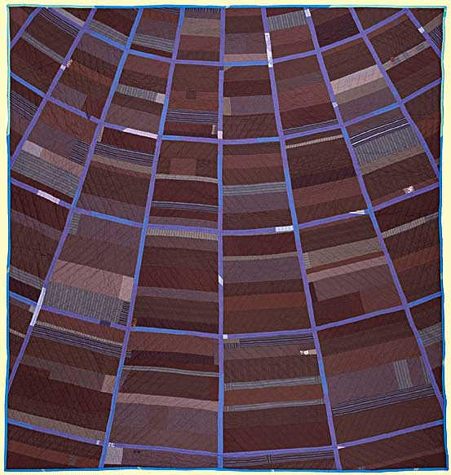
Untitled vanishing point quilt, Sarah NIshiura 2014

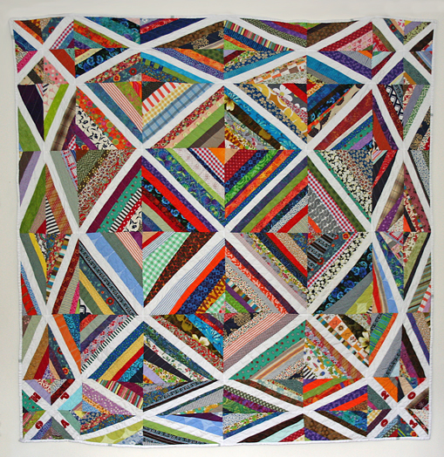

Paper pieced community quilt designed by Sarah Nishiura, sewn by Hyde Park Art Center community members, 2010
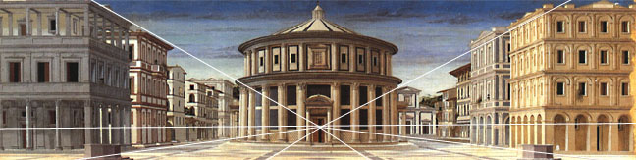
View of an Ideal City, Piero della Francesca, ca. 1480.
Movement in Squares, Bridget Riley, 1961

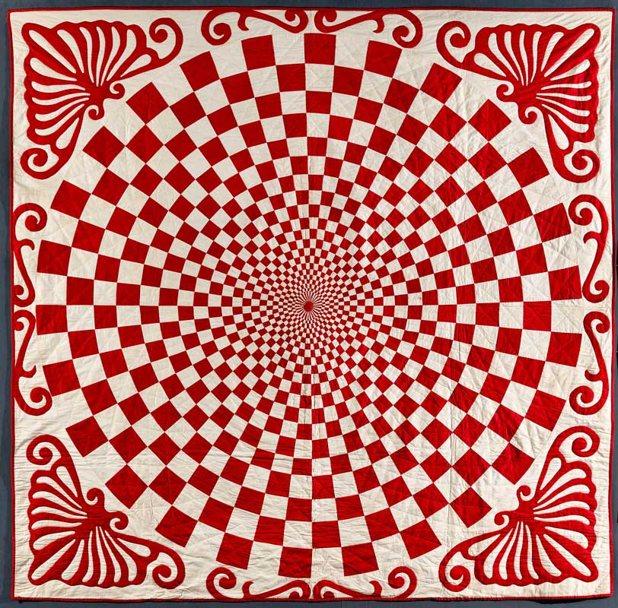
Anonymous red and white quilt from the Joanna S. Rose collection, and featured in the Exhibition "Infinite Variety: Three Centuries of Red and White Quilts", March 2011

