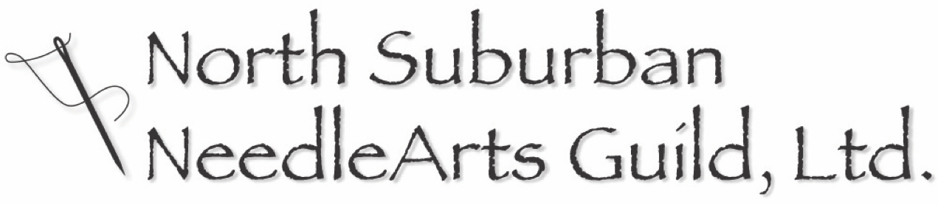

www.nsng.org

2019-2020 Membership Application

NAME: ____________________________________________________
ADDRESS: ____________________________________________________
____________________________________________________
PHONE: ____________________________________________________
E-MAIL: ____________________________________________________
WEB ADDRESS: ___________________________________________________
Send this form, with both sides completed, and your check to:

Dues for 2019-2020 are $50.00
Please make checks payable to NSNG.
NSNG Membership
PO Box 2424
Northbrook, IL 60062

NSNG is a volunteer organization – your help is needed!
There are many opportunities to participate. Please consider the following:
□ YES Board Member - essential for NSNG’s existence & more fun than you’d think. See the Membership Handbook for description of positions.
□ YES Assistant at a Workshop - indispensable and appreciated by the teacher & participants. Guidelines are available. Basically, assist and provide lunch for the teacher, treats for the classroom (reimbursed), in the workshop you are attending.
□ YES Transport a Speaker - necessary for the lecture and classes to occur.
May include airport runs (O’Hare) and/or hotel pick-up (at Milwaukee & Euclid-Lake, Glenview)

I am interested in:

□ Beading
□ Crocheting
□ Doll Making
□ Fabric Dyeing
□ Felting
□ Hand Embroidery
□ Knitting
□ Machine Emb.
□ Needlepoint
□ Needle Lace
□ Paper/Book Arts
□ Quilting
□ Surface Design
□ Wearable Art
□ Weaving
□ Other________

Date Paid: _____________ Check #____________ See other side 

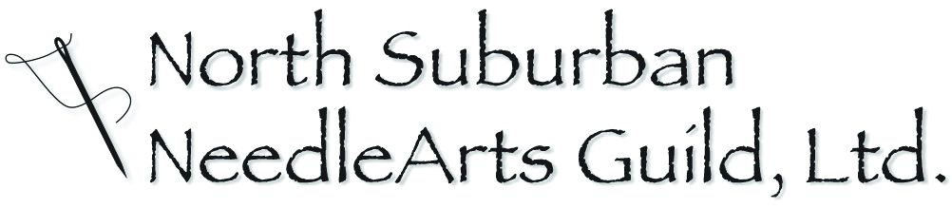
PARTICIPANT AGREEMENT (Including assumption of risks and agreements of release and indemnity)
I, ____________________________________ , in consideration of the privilege of participating in one or more activities hosted by the North Suburban NeedleArts Guild (NSNG), an Illinois not for profit corporation, acknowledge, understand and agree as follows:
I understand that this activity will expose me to a variety of risks including but not limited to the use of heat (including irons and implements for heating metal), sharp tools (including scissors, rotary cutters, and knives), lifting and handling heavy items, risks of moving about the premises in or on which the activities are conducted, and the conduct, including the careless conduct, of other participants. These and other risks are inherent in the activity -- that is, without them the activity would lose its basic character and appeal. Risks of the activities could cause harm, including serious harm, to myself and others, and to my property and property of others.
I acknowledge and assume ALL risks of participating in an activity hosted by NSNG, whether or not described above and inherent or not, and accept full responsibility for risks and dangers to myself or to my property, and for loss or damage caused by me to others or to their property.
In addition, I release, and agree to indemnify (that is, to defend and pay) and not to sue NSNG, its officers, directors and staff, including volunteers (“released parties”) with respect to any claim of any nature whatsoever related in any way to my being enrolled in or participating in an activity hosted by NSNG. The agreements of release and indemnity include claims of negligence of a released party, but not claims of gross negligence or intentionally wrongful conduct.
I have carefully read this agreement, understand it and voluntarily agree to its terms including the assumption of risks, release and indemnity. I agree that it will apply to all activities hosted by NSNG, taking place between September 1, 2019 and August 31, 2020, unless and until replaced by a new agreement pertaining to subsequent activities.
Printed Name:
Signature:
Address:

Date signed:

